South West Australian Coast Food Web
- Cut out the organisms from the food web. (You can choose to use ALL cards or the first 3 rows)
- Start by arranging the producers at the bottom of the page. (Read the organism information to help you)
- Arrange your primary, secondary, tertiary and quaternary consumers. (You do not need to use all organisms)
- Glue your organisms to your page.
- Add the arrows to show the direction of energy.
- Colour code your organisms by colouring in the bottom left corner of each organism card. (Remember some consumers may be more than one type)

Key
Producer
Primary Consumer
Secondary Consumer
Tertiary Consumer
Quaternary Consumer

Glue the producers here.

Organism Information
Abalone: Gets its energy from Algae.
Algae: Produces its own energy from the Sun.
Australian Pilchard: Consumes Zooplankton for energy.
Bronze Whaler: Consumes King George Whiting, Western Blue Groper, Western Australian Salmon, Pink Snapper and Squid.
Hooded Plover: Wades through the shallows looking for Pipis to eat.
Humans: Fishes for King George Whiting, Silver Trevally, Western Blue Groper, Port Jackson Sharks, Octopus and Squid.
King George Whiting: Preys on Pipis and Squid.
Octopus: Eats Sand Crabs.
Phytoplankton: Produces its own energy from the Sun.
Pink Snapper: Eats Australian Pilchard.
Pipis: Gets energy from Zooplankton.
Port Jackson Shark: Eats Southern Rock Lobster and Sea Urchin.
Sand Crab: Feeds on Sea Weed and Sea Cucumber.
Sea Cucumber: Gets energy from Phytoplankton
Sea Dragon: Gets energy from Zooplankton.
Sea Stars: Get energy from Sea Urchins.
Sea Urchin: Gets energy from Algae.
Sea Weed/Detritus: Produces its own energy from the Sun.
Silver Trevally: Eats Pipis.
Southern Eagle Ray: Eats Pipis.
Southern Rock Lobster: Eats Abalone, Sea Urchin and Pipis.
Squid: Gets energy from Australian Pilchard and Sand Crabs.
Western Australian Salmon: Feeds on Australian Pilchard.
Western Blue Groper: Eats Sea Urchin and Pipis.
Zooplankton: Gets energy from Phytoplankton.
FOOD WEB ORGANISM CARDS
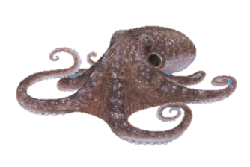Octopus | 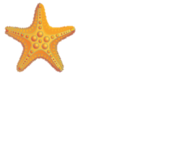  Sea Stars |  | 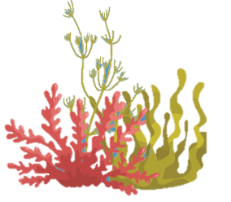  Algae |  | 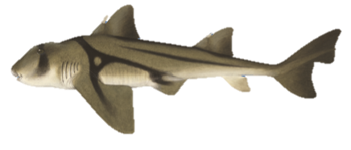  Port Jackson Shark
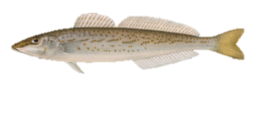  King George Whiting | 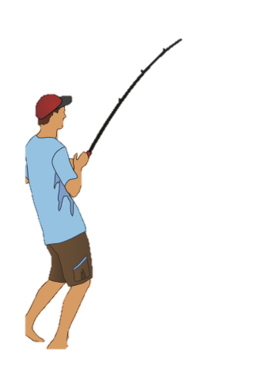  Human |  | 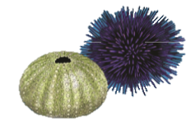  Sea Urchin |  | 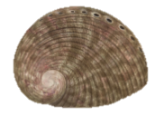  Abalone
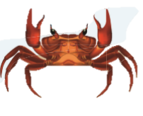  Sand Crab | 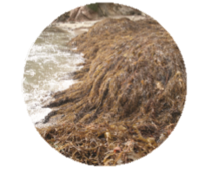  Sea Weed/ Detritus |  | 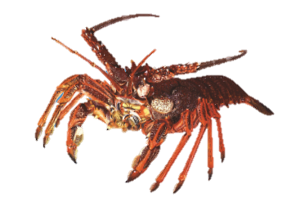  Southern Rock Lobster |  | 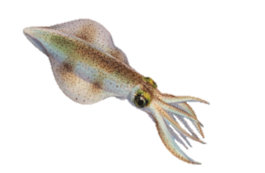  Squid
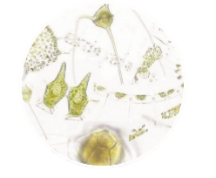  Phytoplankton | 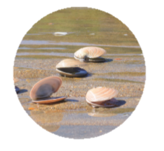  Pipi |  | 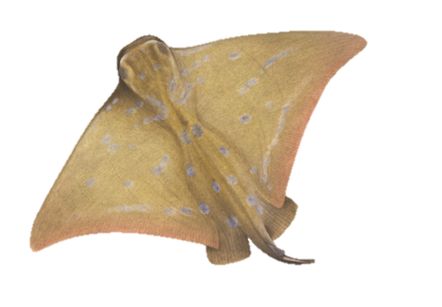  Southern Eagle Ray |  | 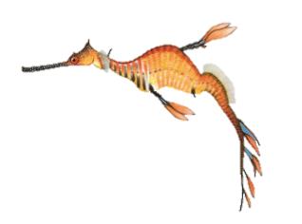  Sea Dragon
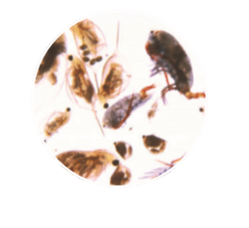  Zoo Plankton | 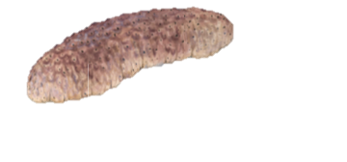  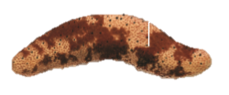  Sea Cucumber |  | 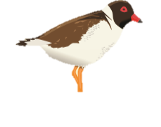  Hooded Plover |  | 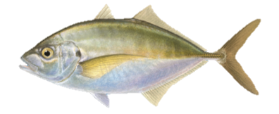    Silver Trevally
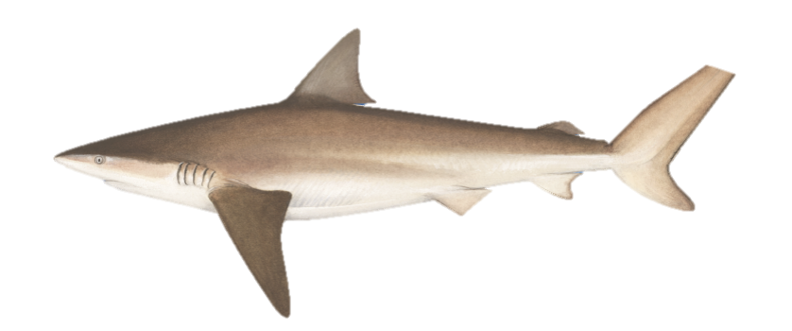  Bronze Whaler |  |  | 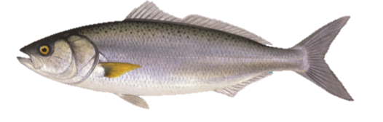  Western Australian Salmon
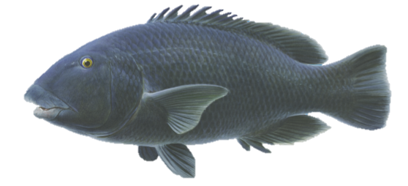  Western Blue Groper |  | 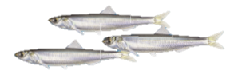  Australian Pilchard |  | 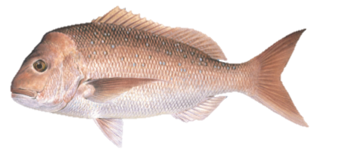  Pink Snapper

